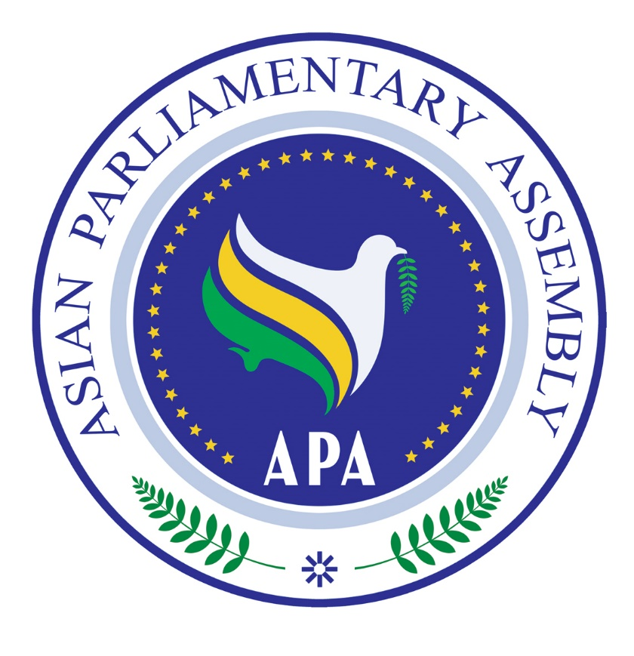
Agenda of
"APA Coordination and Cooperation meeting in the sideline of
138th IPU Assembly"
Saturday,24 March 2018
Geneva, Switzerland

Time | Subject
9:30-9:40 | H.E. Mr Ismail Kahraman, President of APA, "Welcome Speech"
9:40-9:50 | H.E. Dr Mohamad Reza Majidi , Secretary General of APA , "Annual report of the Secretary General on the activities of the APA in 2017"
9:50 -10:00 | H.E. Dr Mohamad Reza Majidi, Secretary General of APA, Delivering APA “Agenda for 2018” (Activities of Sub-Committees and other bodies)
10:00 -10:30 | Emergency Items
10:30- 11:15 | Discussion
11:15- 11:30 | Other Matters

